Biography ‘Conjunto Angola 70’

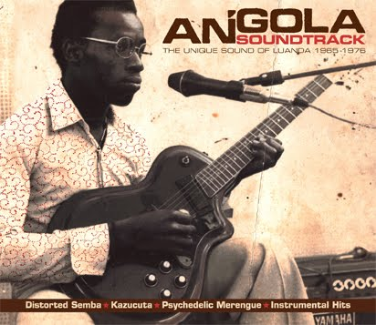
Africa in the 1970s was, in more ways than one, a revolutionary hotbed. Through the euphoria of national independence or the hardship of civil strife, Africans seized the opportunity to re-establish their identity by reinventing their sound - the lifeblood of their tradition. Extraordinary rhythmic revolutions consumed the continent, culminating into what is without question the most enlightened era of African music. Angola's capital Luanda in particular was a headquarter for one of the strongest forces propelling the pan-African music movement.

As the successful fight for independence manifested into a tragic civil war, deeply inspired Angolan musicians produced some of the most sophisticated and beautiful sounds which most of the world has yet to hear. A powerful confluence of traditional rhythms from Luanda’s islands, psychedelic guitar sounds imported from neighbouring Congo, latin grooves, old-school Caribbean merengue and the hard beat of the Angolan carnival bands blended to create the rich and emotional modern music of Angola. Rhythms such as rebita, kazukuta, semba and merengue, to name just a few, comprise the vast array of Angola's golden age of music - captured and compiled on the successful "Angola Soundtrack", Analog Africa's ninth release.

Unfortunately, the sweet sounds of the former Portuguese colony's musical heyday have almost completely disappeared, making only shy appearances during the annual carnival in Luanda. The diversity of instruments such as the dikanza, also known as the "reco reco" - a device indigenous to Angola and Sao Tomé that once defined the Afro-Lusophone sound - have become non-existent in contemporary Angolan music. A particularly special trait from Angola in the 1970s – and possibly the most defining - was the guitarists' ability to produce truly hypnotic and psychedelic riffs by manipulating the instrument in a way that one would find difficult to replicate today.
To resurrect the country's formidable vintage music scene and incorporate all that has been lost through the years, an all-star band consisting exclusively of Angola's finest talent from its golden generation of instrumentalists, composers and vocalists has been formed. The guitarists involved in this project remember their trade secrets and the self-invented fine tuning they mastered. The same brands and models of instruments (Teisco and Höfner guitars and Roland's analog space echo effects) - relied heavily upon during this time period - will also be used to create the most authentic and fantastic sound possible.

In collaboration with Dutch tour organizer RASA and the Goethe-Institute, Samy Ben Redjeb - Analog Africa's founder - and Luanda's Mano a Mano Produções have painstakingly managed to bring together the abundant world-class talent from Angola's turbulent golden era of music. The original anchor of the project, Os Bongos' Boto Trindade (composer of "Pachanga Maria" and guitarist of "Kazucuta"), recommended still-active comrades from the 1970s who joined him in the mission to recreate the lost sound of Luanda. With Boto's essential backing, the core of the band took shape: Joãozinho Margado (percussion/Negoleiros do Ritmo), Teddy N'Singui (guitarist/Inter-Palanca) - current leader of the national radio band and considered by many as the best lead guitarist in the country - Raúl Tolingas (dikanza/Conjunto Kissanguela) and Gregorio Mulatu (lead singer/Aguias Reais). In addition to these class acts, the rythmic backbone of this troupe will consist of Angolan legends Chico Montenegro (singer & bongos/Jovens do Prenda), Carlitos Timótio (bass/Africa Show) and Dulcio Trindade (rhythm guitar/David Zé's FAPLA Povo).

A piece of forgotten history and the treasured repertoires that once serenaded one of Africa's most vibrant and picturesque coastal capitals are set to be reborn across Europe with a group of legendary musicians who, amongst others, spearheaded the revolution of the Angolan sound and have now come together under the name "Conjunto Angola 70".

